**TASK 1**

#include<iostream>

using namespace std;

int main()

{

float marks[4];

float sum = 0,avg;

string courses[4] = {"PF","OOP","CAL","AP"};

for(int i = 0 ; i < 3; i++)

{

cout<<"Enter marks of student"<<i+1<<endl;

for(int j = 0; j<4;j++)

{

cout<<"Marks of "<<courses[j]<<":";

cin>>marks[j];

}

for(int j = 0; j<4;j++)

{

sum+=marks[j];

}

cout<<"Total marks:"<<sum<<endl;

avg = sum/4.0;

cout<<"Average"<<avg<<endl;

if(sum>=90)

cout<<"Grade:A+"<<endl;

else if(avg>=86)

cout<<"Grade:A"<<endl;

else if(avg>=82)

cout<<"Grade:A-"<<endl;

else if(avg>=78)

cout<<"Grade:B+"<<endl;

else if(avg>=74)

cout<<"Grade:B"<<endl;

else if(avg>=70)

cout<<"Grade:B-"<<endl;

else if(avg>=66)

cout<<"Grade:C+"<<endl;

else if(avg>=62)

cout<<"Grade:C"<<endl;

else if(avg>=58)

cout<<"Grade:C-"<<endl;

else if(avg>=54)

cout<<"Grade:D+"<<endl;

else if(avg>=50)

cout<<"Grade:D"<<endl;

else

cout<<"Grade:F";

}}

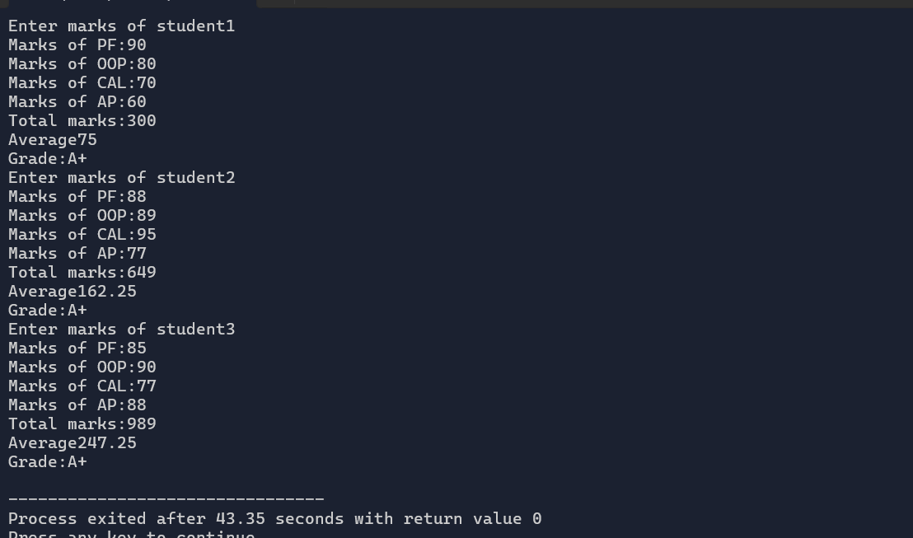

**TASK 2:**

#include<iostream>

using namespace std;

int main()

{

string e1[5];

string e2[5];

cout<<"Enter max 5 participants for event 1(quit to exit):"<<endl;

int i = 0;

while(i<5)

{

cin>>e1[i];

if(e1[i]=="quit")

break;

i++;

}

int j =0;

cout<<"Enter max 5 participants for event 2(quit to exit):"<<endl;

while(j<5)

{

cin>>e2[j];

if(e2[j]=="quit")

break;

j++;

}}

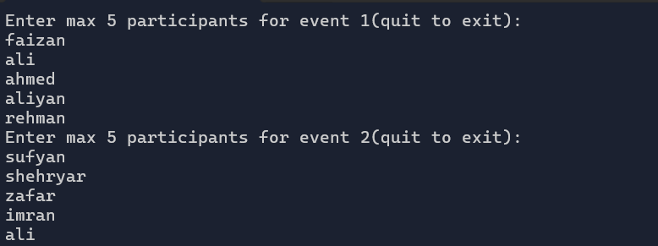

**TASK 3:**

#include<iostream>

using namespace std;

int fibo(int n)

{

if(n==0)

return 0;

if(n==1)

return 1;

return fibo(n-1)+fibo(n-2);

}

int main()

{

int n;

cout<<"Enter nth term:"<<endl;

cin>>n;

cout<<"Fibonacci series"<<endl;

for(int i = 0 ; i<n;i++)

cout<<fibo(i)<<endl;

}

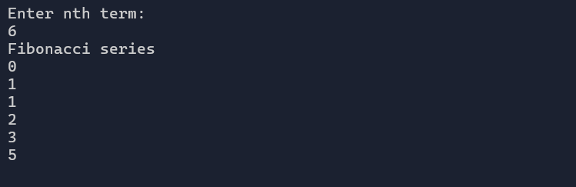

**TASK 4:**

#include<iostream>

#include <algorithm>

using namespace std;

int main()

{

string s;

cout<<"Enter a string:"<<endl;

getline(cin,s);

reverse(s.begin(),s.end());

cout<<"Reversed string:"<<s;

}

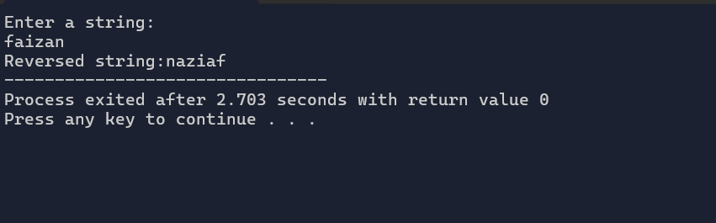

**TASK 5:**

#include<iostream>

using namespace std;

int main()

{

int n,m;

cout<<"Enter the size of array:"<<endl;

cin>>n;

int arr1[n];

int arr2[n];

cout<<"Enter values of array 1"<<endl;

for(int i = 0; i<n;i++)

{

cin>>arr1[i];

}

cout<<"Enter values of array 2"<<endl;

for(int j = 0; j<n;j++)

{

cin>>arr2[j];

}

int t;

for(int i = 0; i<n;i++)

{

t = arr1[i];

arr1[i] = arr2[i];

arr2[i] = t;

}

cout<<"Values of array 1 after swapping:"<<endl;

for(int i = 0; i<n;i++)

{

cout<<arr1[i]<<endl;

}

cout<<"Values of array 2 after swapping:"<<endl;

for(int j = 0; j<n;j++)

{

cout<<arr2[j]<<endl;

}

int max;

max = arr1[0];

for(int i =0;i<n;i++)

{

if(arr1[i]>max)

max = arr1[i];

}

int k;

cout<<"Largest element from array 1 after swapping:"<<max<<endl;

for(int i = 0; i<n;i++)

{

for(int j = i+1;j<n;j++)

{

if(arr2[i]<arr2[j])

{

k= arr2[i];

arr2[i] = arr2[j];

arr2[j] = k;

}

}

}

cout<<"Second largest element from array 2 after swapping:"<<arr2[1]<<endl;

}

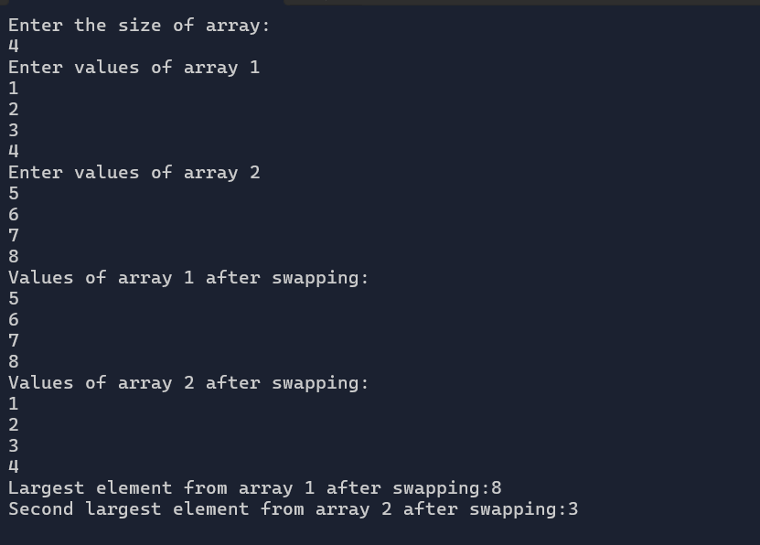

**TASK 6:**

#include<iostream>

using namespace std;

int main()

{

float units;

float cost;

cout<<"Enter total units consumed:";

cin>>units;

if(units<=50)

cost = units*0.50;

else if(units>50)

cost =(units-50)*0.75+50*0.50;

else if(units<=250)

cost = 50*0.5 +100*0.75+(units-100)*1.20;

else if(units>250)

cost = 50*0.5 +100*0.75+100*1.20+(units-250)*1.50;

cost+=0.2;

cout<<"Total cost is:"<<cost;

}

**TASK 7:**

**#include<iostream>**

**#include<time.h>**

**using namespace std;**

**int coinToss(){**

**return rand()%2;**

**}**

**int main()**

**{**

**int n;**

**cout<<"Enter no of times to toss coin:";**

**cin>>n;**

**srand(time(0));**

**int r;**

**for(int i = 0; i<n;i++)**

**{**

**r = coinToss();**

**if(r==1)**

**cout<<"Heads"<<endl;**

**else**

**cout<<"Tails"<<endl;**

**}**

**TASK 8:**

#include<iostream>

#include<stdlib.h>

using namespace std;

int main()

{

int arr1[] = {10,15,2,78,92,25};

int arr2[] = {8,41,32,21,98,33};

int arr3[6] = {0};

for(int i = 0; i<6;i++)

{

if(arr1[i]>arr2[i])

{

arr3[i] = arr1[i]+arr2[i];

}

else if(arr1[i]<=arr2[i])

{

arr3[i] = (arr1[i]+arr2[i])/2;

}

}

cout<<"Array 1"<<endl;

for(int i =0;i<6;i++)

cout<<arr1[i]<<endl;

cout<<"Array 2"<<endl;

for(int i = 0 ; i < 6;i++)

cout<<arr2[i]<<endl;

cout<<"Array 3"<<endl;

for(int i =0;i<6;i++)

cout<<arr3[i]<<endl;

}

